LASHINGS WORLD XI v BROXBOURNE CC
The Legends Return

Friday 24th July – 11:30am – Late

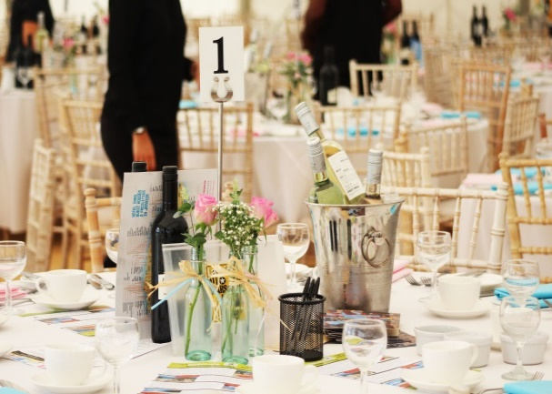
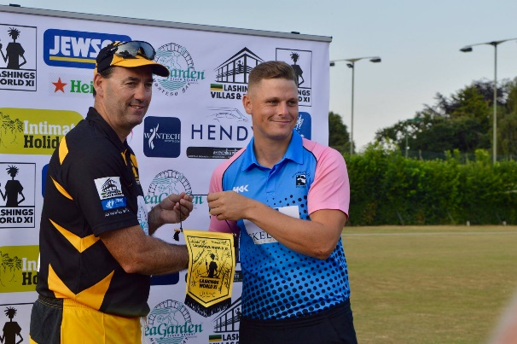

Some of the greatest names in world cricket will once again be playing at Broxbourne Cricket Club on Friday 24th July 2020. The 2020 squad includes Mark Ramprakash, Simon Jones, Devon Malcolm, John Emburey, Adam Hollioake, Chris Lewis, Saqlain Mushtaq and most probably Tino Best, Curtly Ambrose and Courtney Walsh among other great names from the recent past.

This is your chance to treat clients, friends, or family to a glittering afternoon of entertainment in the presence of some of the best cricketers to have ever played the game at our wonderful Mill Lane venue with, it is planned, that the one and only Henry Blofeld will again commentate on the match against Broxbourne's exciting young first team.

The following packages are on offer:

Platinum Package
This package is available for 1 main sponsor and includes:

- Table for ten for lunch plus your choice of one of the Lashings World XI players to sit on your table
- Champagne on arrival
- 3 course meal and 4 bottles of house wine
- Pre and post match entertainment in the marquee
- Your company name on all pre and post match publicity material
- Company logo on match day menus
- 20/20 cricket match between Lashings World XI and Broxbourne
- Presentation of the man of the match award
- Opportunities for autographs and photos with the Lashings players
- Free social membership for you and your family for a year at Broxbourne Sports Club
- 4 tickets for the Club's annual gin festival which will be held at the end of June

£2000 + VAT for companies

Gold Package
This package is available for 12 sponsors and includes:

- Table for ten with one of the Lashings World XI players on your table
- Champagne on arrival
- 3 course meal and 4 bottles of house wine
- Pre and post-match entertainment in the marquee
- Company logo included on match day menus
- Opportunities for autographs and photos with all the Lashings players
- 20 /20 cricket match between Lashings World XI and Broxbourne CC

£750 + VAT for companies
£750 for private individuals

Silver Package
This package is available for 18 sponsors and includes:

- Table for ten
- Champagne on arrival
- 3 course meal and 2 bottles of house wine
- Pre and post-match entertainment
- Opportunities for autographs and photos with all the Lashings players
- 20/20 cricket match between Lashings World XI and Broxbourne CC

£650 + VAT for companies
£650 for private individuals

Individual, group or company tickets for the dinner are priced at £75 for a table hosted by a Lashings player (subject to availability) or £65 for a non-hosted table.

The marquee will be open from 11.30 am and the bars shortly after. Lunch will include entertainment and various fund raising activities hosted by Lashings World XI and will conclude with a grand auction. Ticket prices include all of the detail above. After the match there will be post match music entertainment in the marquee and food will be available. The bars will be open until 11.30 pm.

If you are unavailable to attend the lunch, the match against the Lashings World XI will commence at roughly 16:00 with, it is planned, the legendary former test match special commentator Henry Blofeld providing commentary on the match. Admission for club members and U16s will be free of charge, with a charge of £5 for adults who are not members of the Club.

Order of Play

11:00 Junior Coaching Starts
11:30 Guests Start To Arrive
12:30 Call For Lunch
15:00 Auction Starts
16:00 Match Begins
19:30 Closing Ceremony
20:00 Evening Entertainment

*all timings are approximate

Keep up to date with everything at Broxbourne CC via the following methods –

Facebook Broxbourne Cricket Club
Twitter @BroxbourneCC
Instagram @BroxbourneCC
Website http://broxbourne.play-cricket.com/

If you want to join us for what should again be another great day of dining, drinking, entertainment and top quality company and cricket please contact the Cricket Club Treasurer Richard Grove on groric6@aol.com or 07985 029285.

If you would also be interested in sponsoring the cricket club or becoming a match day sponsor in 2020 please contact Richard.

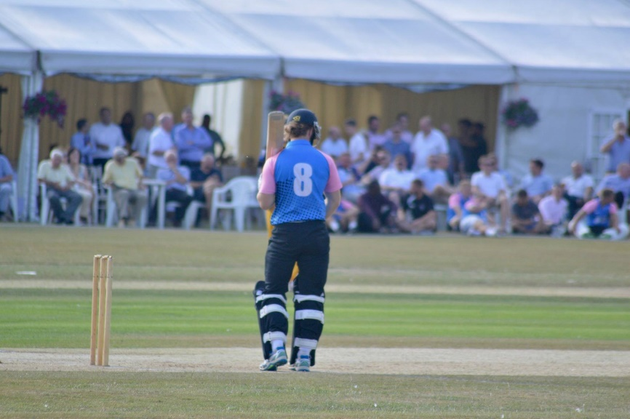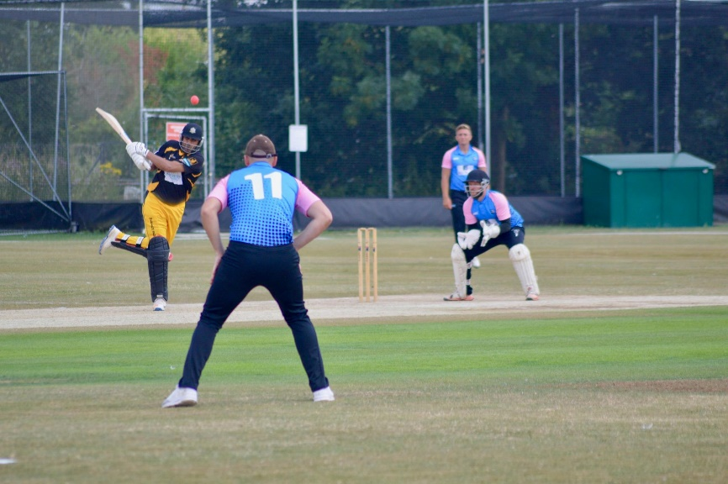
Thanks to our main sponsors Skeltons Wealth Management for their continuing support.

